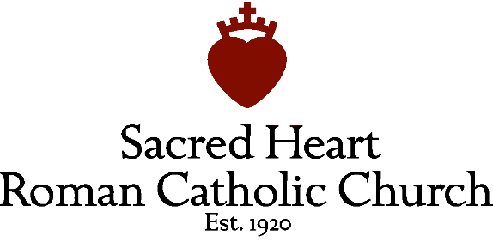
Family Catechesis Program / 2023-2024
One form per child
Registration Fee $50 per child

Child’s Name ________________________________________ Date of Birth __________________
Address ____________________________________________________________________________
Phone ______________________________ Cell Yes or No Alternate Phone # ______________
Grade of Student in Fall ___________________ School ___________________
Mother’s Name _____________________________ Mother’s Email ____________________________
Father’s Name _____________________________ Father’s Email ____________________________
Mother’s Mobile# ___________________________ Father’s Mobile# ___________________________

Are you registered parishioners with Sacred Heart Church? Yes or No Attend ___4:30 Sat ___10:00 Sun ___12:00 Sun
Registration with and Mass attendance at Sacred Heart is a requirement to participate in the Family Catechism program.
Which Sacrament(s) has your child received? Please note the date, church name, city/state.
Baptism ____________________________________________________________
Reconciliation ____________________________________________________________
Holy Eucharist ____________________________________________________________
Confirmation ____________________________________________________________
The Diocese of Charleston requests two years of continuous catechesis in order to receive a Sacrament. Verification of two years of catechism is required.
Is your child planning to receive Sacrament(s) this year or next? If so, which one(s)? ____________________________

Please note any information you feel would be beneficial for us to know about your child or family.

Please return form to the parish office or in collection basket or email it to Sandy Funk, Family Catechism coordinator, at shcreligioused@charlestondiocese.org. Feel free to email or call Sandy at 843.469.3377 with questions.

